**Altitude Basketball Website**

**Pitch:**

Information on program

Info on coaches

Philosophy of the program

Link to social media pages

Contact page

Events Page: all the games for all the teams are listed

Team store link

**Purpose:**

The purpose of this website is to be a landing page for current members of Altitude Basketball club. It will be a place for them to see events, and connect with the club. Another purpose would be for parents and kids who are interested in joining Altitude Basketball to have a place to get information about the club, and be able to contact us.

**Audience:**

The audience for this website will be the families who are either already part of Altitude Basketball or who are wanting information on the club.

**Three topics:**

Club Introduction (Home)

Coach Information

Team Merchandise

**Introduction**

Altitude Basketball is a club for girls in 3rd-8th grades in Colorado Springs, CO. This program was created in 2017 by, Monte Murdock, a father who wanted to give his young daughters a chance to grow and refine their basketball skills before heading into high school. Monte already had two older daughters in the Pine Creek High School Women’s Basketball Program, and saw the potential of starting a feeder program, not only his daughters but also the other girls who would eventually play on the same high school team. With a highly skilled sport like basketball starting early is often the key to success, and playing with the same group of girls for a long period of time helps the success of the team as a whole. So, the Pine Creek High School feeder program: Altitude Basketball, was born.

**Growth**

As the program grew, and girls continued to hone and improve their skills, what started as a single team has become one of the largest programs in the city. In August of 2022, five years after its inception, Altitude Basketball boasts over 40 players, 8 coaches, and 5 teams that regularly play in competitive leagues and tournaments in the Colorado Springs/Denver area.

**Multi-Sport Athletes**

One of the most unique aspects of Altitude Basketball is that instead of requiring or even recommending that players stop playing other sports and focus solely on basketball, we *encourage* our players to play in multiple sports. Michelle Smith, a espnW.com Contributor, wrote a piece in 2016 highlighting the benefits of being a multi-sport athlete where she mentioned that for multi-sport athletes, there were fewer overuse injuries, less opportunity for emotional burn-out, and several other reason to continue playing multiple sports. She said, “Studies show that playing multiple sports leads to better muscle, motor and skill development. It promotes general athleticism, balance, speed, and agility.” [link](https://www.espn.com/espnw/voices/story/_/id/17831948/5-reasons-want-your-kid-multi-sport-athlete) As a club we try to keep games to Saturdays whenever possible so that Sundays can be set aside for other sports, or family obligations.

**Run by Volunteers**

Another unique part of Altitude Basketball is that it is run entirely by volunteers. Our owner, administrator, and coaches are all volunteers who love basketball, and want to help bring it to the next generation of players. This keeps the fees for the club relatively low compared to other for-profit organizations in the area.

We will continue to grow and learn, as players, coaches and as an organization. If you want to join us click here!

**Our Mission Statement:**

“The Altitude Basketball program was formed in 2017 to accommodate multi-sport athletes who desired highly-competitive basketball without the cost and time commitment of many programs that require exclusivity and frequent out-of-state travel. Altitude coaches are dedicated volunteers with prior coaching or playing experience. Altitude generally practices twice a week in the evenings and participates in leagues and tournaments principally on Saturdays. Altitude Basketball has quickly become the premier girls’ basketball program in Southern Colorado and serves as the principal feeder program for Pine Creek HS Women’s basketball.”

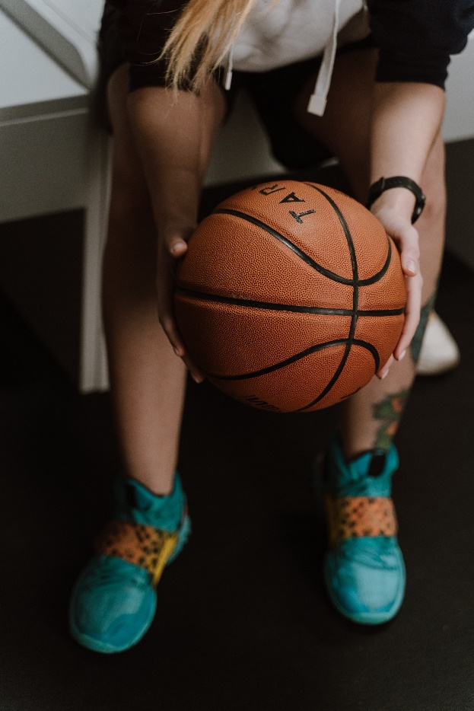 

Image from Pexels contributor: Cottonbro Image from Unsplash contributor: bailey burton

**Coaches**

All Altitude coaches are dedicated volunteers with prior coaching or playing experience, who work to help their players, and their team as a whole improve in the game of basketball. While each coach has their own unique methods and style, all coaches stay within our club’s coaching philosophy.

**Coaching Philosophy**

1. We teach kids how to play basketball, not how to run plays. Set plays have their place but practicing them should be a VERY minimal part of club practice if at all. Perhaps 1 or 2 inbounds plays. Maybe one set piece, especially for the younger grades. In contrast, we teach the kids how to pass, cut, ball screen, back cut, move without the ball, spacing, off ball screens, ball fake, recognize passing lanes, and more generally how to play in a team environment.

2. We teach kids what specific skills they can work on without the intent of perfecting individual skills in practice. Team oriented concepts should take precedent. It is appropriate to spend some time with a particular shooting or dribbling drill in practice. However, the goal of such a drill is to give kids ideas on what to work on in their own time. No player will ever become a good shooter or dribbler simply by the drills and repetition in practice. There isn't enough time. We strive to minimize time standing in a line, and the bulk of practice time is spent on concepts that kids cannot do on their own, i.e. offensive and defensive team concepts.

3. We teach and praise defensive effort equally or more than offense. Every player can have a night where things don't go right offensively for whatever reason. Every player should be able to impact the game with their defensive skills and knowledge regardless of their offensive aptitude. Players should be taught man defense and different zone defensive concepts. Team defense, help-side, see the ball, see the man and defensive priorities are all important concepts. Defensive priorities are

1. Defend the lane

2. Defend the ball

3. Defend your man (or zone).

4. Everyone shoots, everyone dribbles. We can and should teach kids "their spots" (where they are likely to make a shot) and coach situational dribbling (i.e. not everyone should be encouraged to bring the ball up against a press), but we do not tell a player not to shoot or not to dribble. If the player is on the team we will have enough confidence in them that we don't have to instruct them to "never shoot" or "never dribble".

5. Sportsmanship and positivity. There is no tolerance for cliques, exclusionary treatment, personal criticisms, backbiting, gossipy or "mean girl" behavior. Coaches try to set the tone by complimenting and praising more than critiquing. We praise sportsmanship and positivity.

**Our Coaches**

Monte Murdock (pic)

Dakota DeBoer (pic)

Katrina Summers (pic)

Phil Falender (pic)

Lacey Sanders (pic)

Kelly Schoonmaker (pic)

Chad VanHorn (pic)

Dillion Richards (pic)

(Brief bio or description of team they coach or other roles they have in the organization)



Image by Unsplash contributor Joshua Kantarges

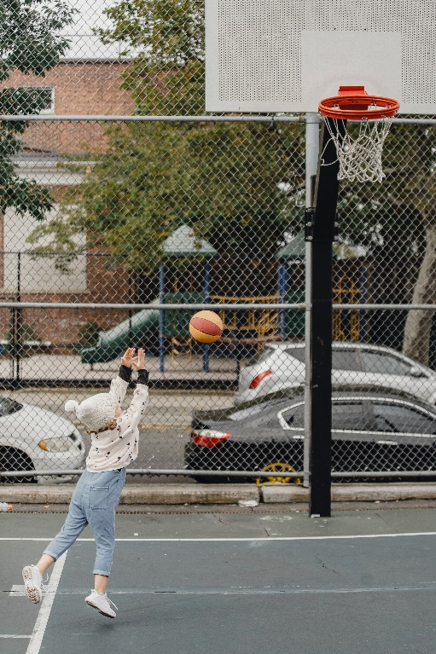 Image by Pexels contributor Allan Mas

**Merchandise:** Click on the link to see all color, style, and size options

**Altitude Mom New**

Premium T-shirt: <https://a.co/d/8171n57>

Sweatshirt: <https://www.amazon.com/dp/B0BLGS3SY8?customId=B078RZCQZR&th=1>

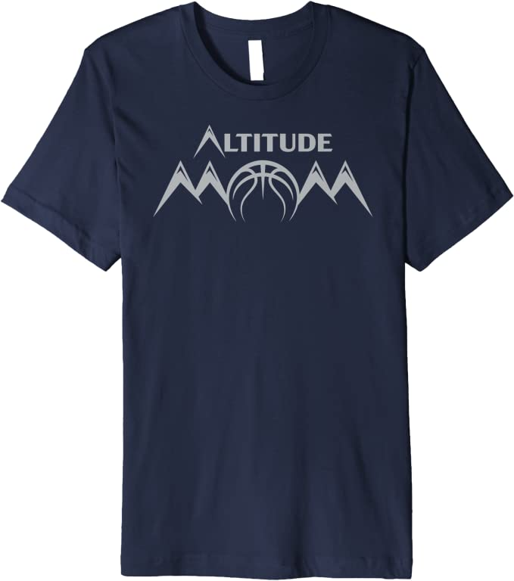

**Altitude Dad New**

Premium T-shirt: <https://a.co/d/0V3kw2f>

Pullover Hoodie: <https://www.amazon.com/dp/B0BLJ282CM>

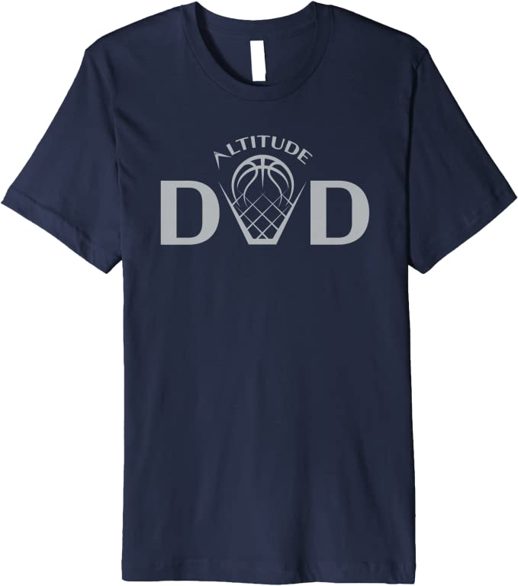

**Altitude Navy New**

Premium T-shirt: <https://www.amazon.com/dp/B0BLHX4C2J?customId=B0753779FX&th=1>

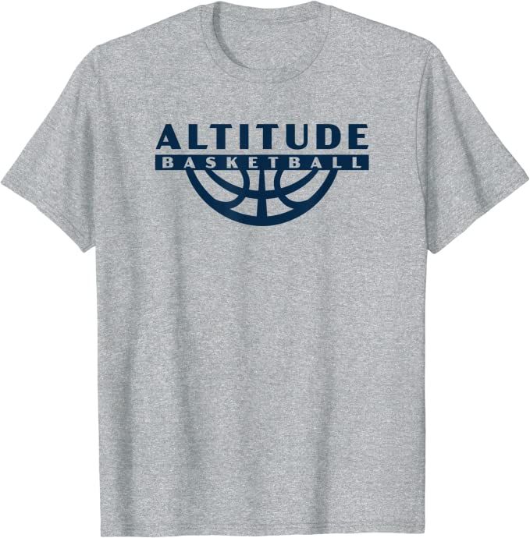

**Full Color Logo**

T-Shirt: <https://a.co/d/6GcdqOS>

Premium T-shirt: <https://a.co/d/aSmkQQS>

Raglan Baseball Tee: <https://a.co/d/b8TG3fj>

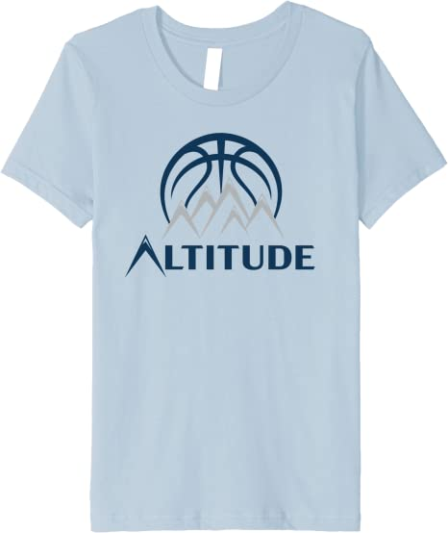

**Large Color Logo with Outline**

Raglan Baseball Tee: <https://a.co/d/2mqW5an>

Long Sleeve Shirt: <https://a.co/d/5TwVeYH>

V-neck T-shirt: <https://a.co/d/5Nkam4I>

Pullover Hoodie: <https://a.co/d/0vvzx3C>

Sweatshirt: <https://a.co/d/b7OFxFt>

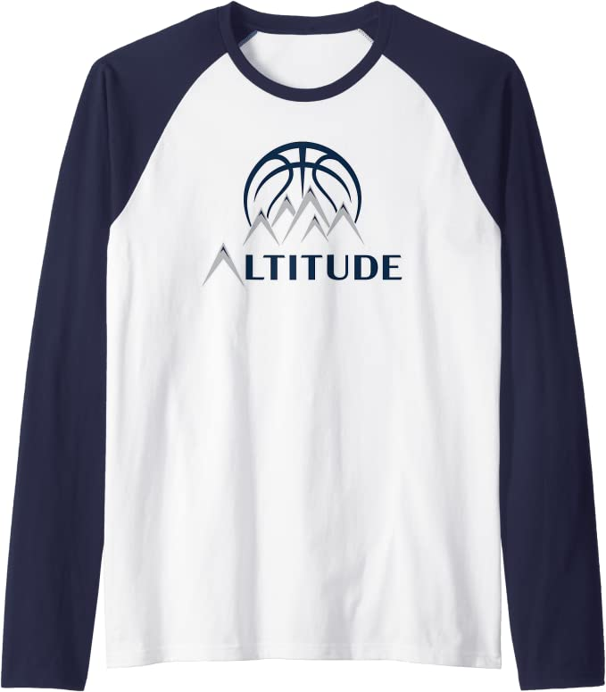

**Navy Logo**

T-shirt: <https://a.co/d/6kFWEzR>

Premium T-shirt: <https://a.co/d/3kIoUqj>

Raglan Baseball Tee: <https://a.co/d/6yqXOWY>

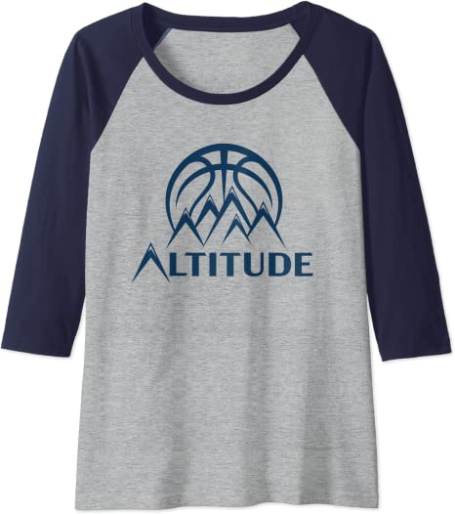

**Silver Logo**

T-shirt: <https://a.co/d/0Zhjbb0>

Long-sleeved T-shirt: <https://a.co/d/0yHAhVa>

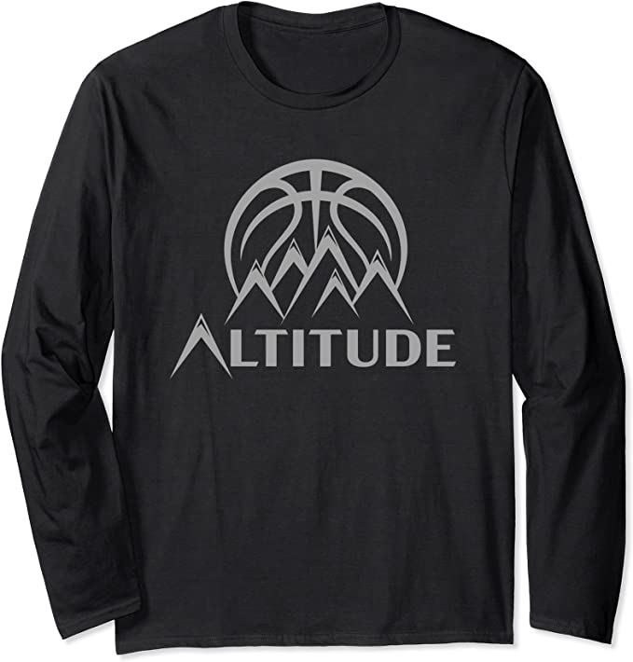

**Small Color Logo with Outline**

Premium T-shirt: <https://a.co/d/26ntdYu>

Sweatshirt: <https://a.co/d/bxbLQUu>

Zip Hoodie: <https://a.co/d/5NKz1p1>

Pull Over Hoodie: <https://a.co/d/5XUAlP9>

Raglan Baseball Tee: <https://a.co/d/6CRPlkx>

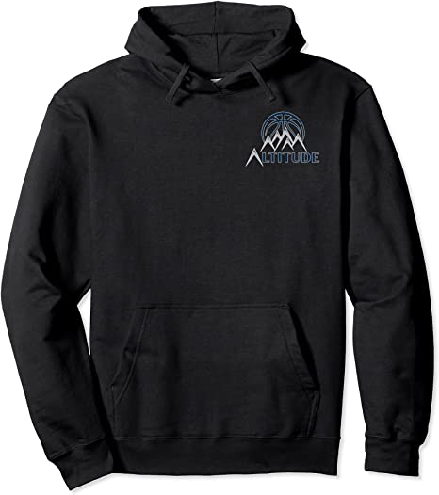

**Phone Cases**

iPhone: <https://a.co/d/g7ykePc>

Samsung Galaxy: <https://a.co/d/aE83AVs>

